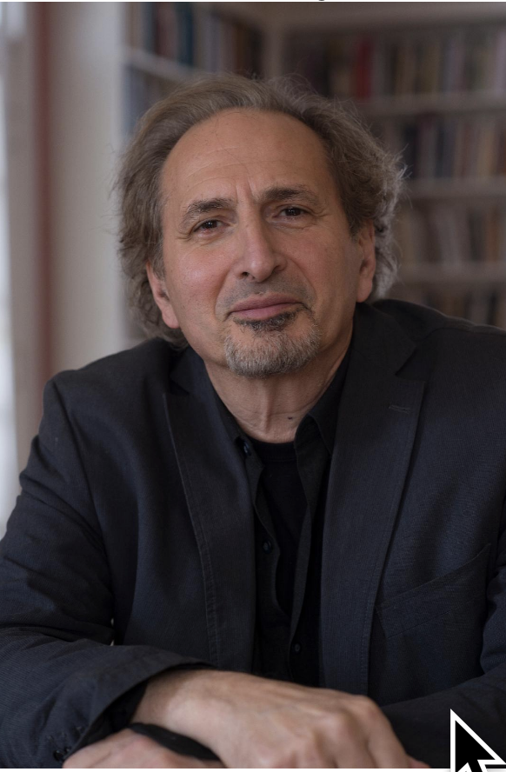

Peter Balakian

Peter Balakian is the author of 7 books of poems, 4 books of prose, 3 collaborative translations and several edited books. Ozone Journal won the 2016 Pulitzer Prize for poetry, Black Dog of Fate, a memoir won the 1998 PEN/Martha Albrand Prize for the Art of the Memoir, and was a best book of the year for the New York Times, the LA Times, and Publisher’s Weekly; The Burning Tigris: The Armenian Genocide and America’s Response won the 2005 Raphael Lemkin Prize and was a New York Times Notable Book and a New York Times Best Seller. His translation of Grigoris Balakian’s Armenian Golgotha: A Memoir of the Armenian Genocide was a Washington Post book of the year. Vice and Shadow: Essays on the Lyric Imagination, Poetry, Art, and Culture was published in 2016.
Balakian is the recipient of many awards and prizes and civic citations: the Pulitzer Prize, The Presidential Medal and the Movses Horanatsi Medal from the Republic of Armenia, Guggenheim Fellowship, National Endowment for the Arts Fellowship, The Spendlove Prize for Social Justice, Tolerance, and Diplomacy (recipients include President Carter); and The Emily Clark Balch Prize for poetry from the Virginia Quarterly Review. He has appeared widely on national television and radio 60 Minutes, PBS News Hour, ABC World News Tonight, Charlie Rose, CNN, C-SPAN, NPR, Fresh Air, etc) , and his work has been translated into many languages and foreign editions including Armenian, Arabic, Bulgarian, French, Dutch, Greek, German, Hebrew, Italian, Russian, Serbo-Croation, and Turkish. He is Donald M. and Constance H. Rebar Professor of the Humanities, Professor of English and Director of Creative Writing at Colgate University, Hamilton, New York, USA.

